1. **Design a Data Warehouse for IPL Cricket Tournament (Asked in Flipkart Interview for Senior Data Engineer role)**

**Grains: -** each row for each match

Dimension table: - team, IPL_vanue, player_details, staff_info

Fact table: - IPL_match, IPL_batsman, IPL_bwoler

|  |  |
| --- | --- |
| Report | Query |
| which team won maximum matches | select count(winning_team_name) as win_count from IPL_Match order by win_count desc; |
| which player got maximum score | select player.name, sum(bats.total_score) as total_score from player_details_dim player inner join ipl_batsman_fact bats on player.player_id = bats.player_id order by total_score desc; |
| which blower got maximum wicket | select player.name, sum(ball.wickets) as total_wickets from player_details_dim player inner join ipl_bowler_fact ball on player.player_id = bats.player_id order by total_wickets desc; |

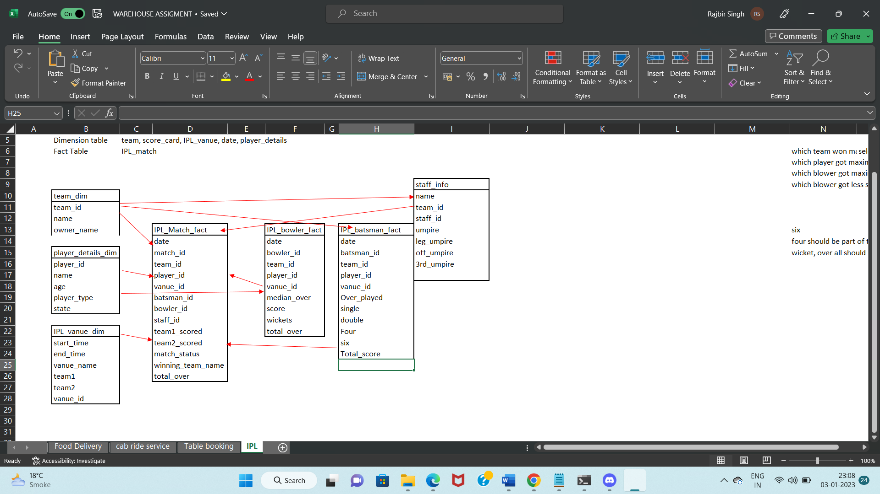

**2. Design a Data Warehouse for Food delivery app like Swiggy, Zomato (Asked in Grab for Data Engineer role)**

|  |  |  |
| --- | --- | --- |
| S.no | Analysis | Queries |
| 1 | How many orders delivered every day | Select date, count(*) as order_count from order_delivery_fact where order_status = ‘delivered’ group by date; |
| 2 | from which city maximum order delivered for last 7 days | Select location.city, order.count(*) as order_count from order_delivery_fact order left join location_details location on order.location_id = location.location_id and order.date between ‘2022-12-23’ and ‘2022-12-30’ group by location.city order by order_count desc; |
| 3 | Total revenue every day | select order.date, sum(payment.total_amount) as total_sales from order_delivery_fact order left join payment_fact payment on payment.payment_id = order.payment_id group by order.date; |
| 4 | Number of cancellations everyday | Select date, order_status as cancellation_count from order_delivery_fact where order_status = ‘Cancel’ group by date; |

**Grains:** - Need to track order delivery transaction

**Dimension tables: -** Date, Customer, Restaurant, Delivery boy, Documents, Vahicle_type, Location

**Fact tables: -** Order delivery & Payment

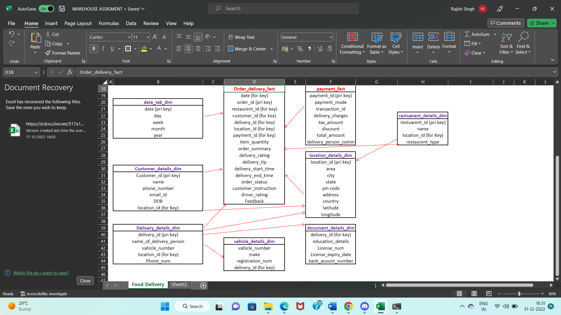

**3. Design a Data Warehouse for cab ride service like Uber, Lyft (Asked in Google for Data Engineer role)**

**Grains:** - need to track individual trip at each transaction

**Dimension tables: -** customer, location, driver, car, document

**Fact tables: -** trip & Payment

|  |  |
| --- | --- |
| **Reports** | **queries** |
| Track ride done by driver and their performance | select driver_id, customer_rating from trip_fact where trip_status = 'completed'; |
| how many rides are happening to a common or famous destination each day | select date, count(*) from trip_fact group by date; |
| How many trips cancelled each day | select start_time, count(*) from trip_fact where trip_status = 'cancelled' group by start_time; |
| How many rides and the average price during the peak hours per day | select date_format(trip.start_time,'%d.%m.%Y') as date, count(trip.trip_status) as rides_count, avg(payment.total_amount) as average_price from trip_fact trip inner join payment on trip.payment_id =payment.payment_id and time(trip.start_time) between '18:00:00' and '21:00:00' group by date; |

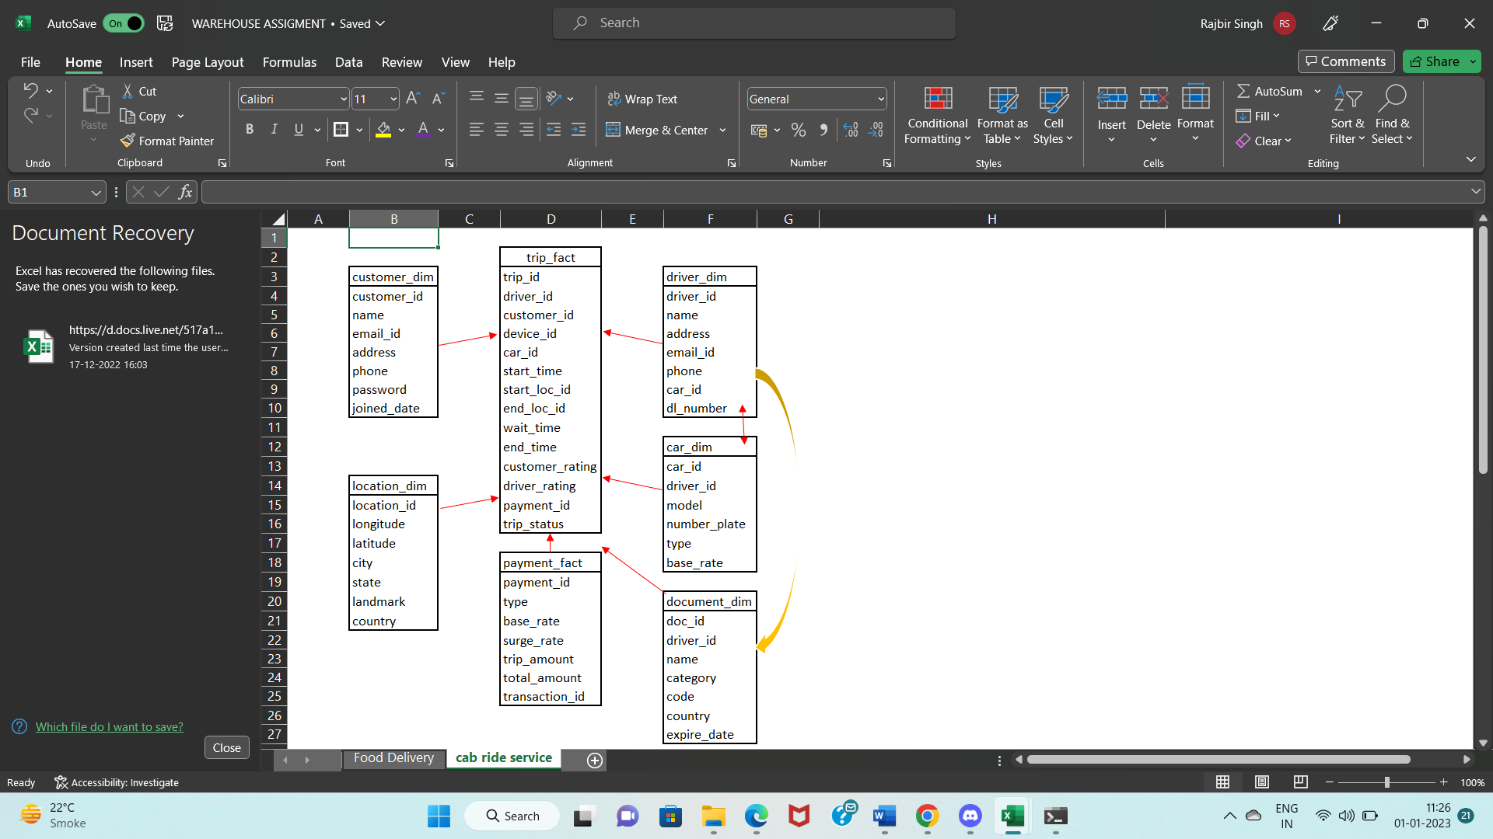

**4. Design a Data Warehouse for Restaurent table booking app like Dineout (Asked in McKinsey for Consultant Data Engineer role)**

Grains: - each row customer's restaurant booking info

Dimension table: - customer, location, restaurant, payment, date, review

Fact table: - table_booking_fact, payment_fact

|  |  |
| --- | --- |
| Report | Queries |
| top 10 restaurant name | select res.name, avg(booking.customer_rating) as rating from table_booking_fact booking inner join restaurant_dim res on res.restaurant_id = booking.restaurant_id order by rating desc limit 10; |
| Lowest rating restaurant | select res.name, avg(booking.customer_rating) as rating from table_booking_fact booking inner join restaurant_dim res on res.restaurant_id = booking.restaurant_id order by rating ; |
| most frequent visit restaurant | select count(restaurant_id) as visit_count from table_booking_fact order by visit_count desc; |

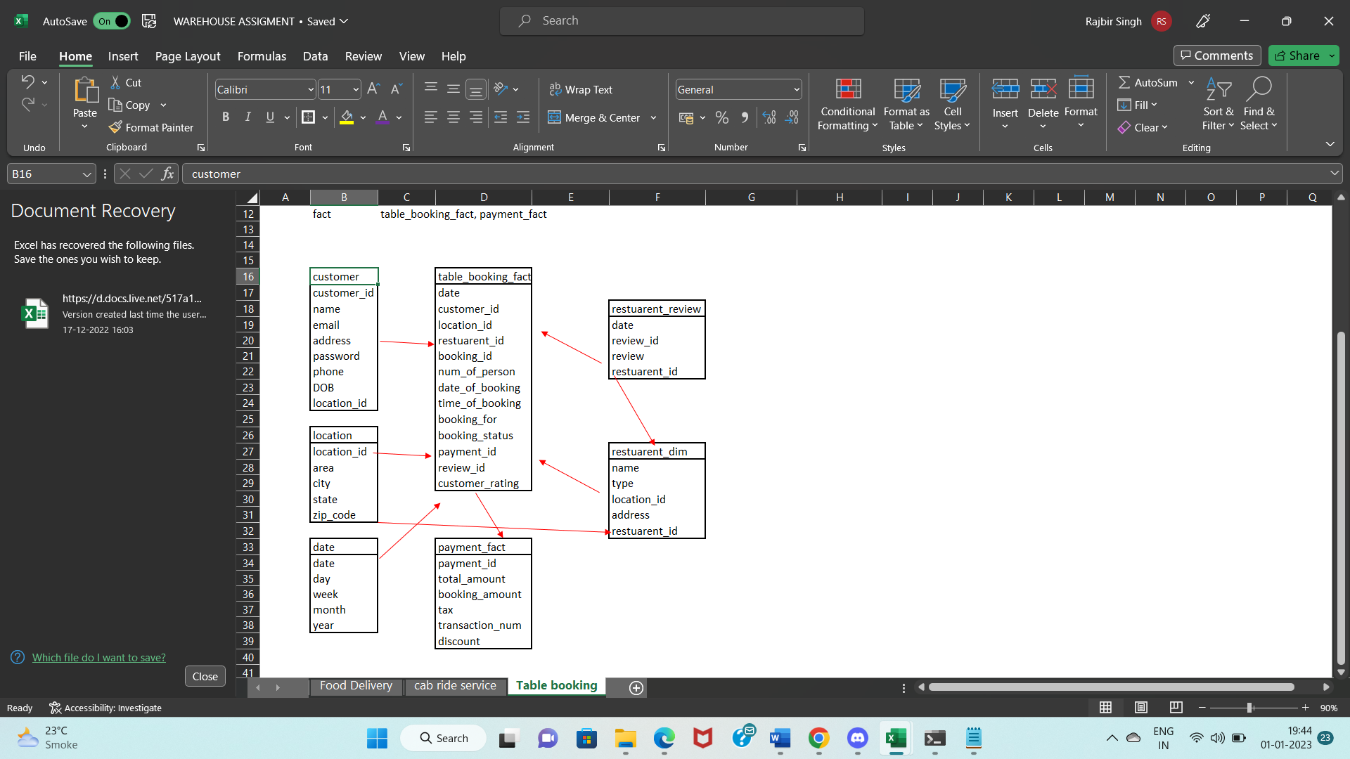

**5. Design a Data Warehouse for Covid Vaccination Application (Asked in Livsapce for Data Engineer role**

**Grains: -** person wise vaccination details in each row

**Dimension tables: -** date, customer, location, vaccine_info_dim, company_info_dim

**Fact table:** **-** covid_vaccination_application_fact

|  |  |
| --- | --- |
| Analysis | Query |
| day wise vaccine count | select date, count(date) as vaccine_count from covid_vaccination_application_fact group by date; |
| which area has got maximum number of vaccine | select location.area, count(covid.date) as area_count from covid_vaccination_application_fact covid inner join location_dim location on location.location_id = covid.location_id group by location.area; |
| proportion of 1st or 2nd dose | SELECT (count(1st_dose)/count(date)) as 1st_dose_propostion, (count(2nd_dose)/count(date)) as 2nd_dose_proportion from covid_vaccination_application_fact; |

